**Optimal Chopstick Length**

Tiffany Comandatore, Bin Fang, Wenjun Jia, & Casey Schmal-Magnuson

**Introduction:**

Have you ever wondered how the length of a chopstick was decided?

In 1991, a study was conducted that investigated the relationship between lengths of a chopsticks and the efficiency of picking up food. The researchers used a Randomized Complete Block Design to investigate the effect of 6 different lengths of chopsticks: 180mm, 210mm, 240mm, 270mm, 300mm, and 330mm.

They randomly selected 31 college-aged male subjects who tried all 6 different lengths. The subjects were the blocks. The response variable was the amount of peanuts pinched and placed in a cup in a certain timeframe.

The goal of this study was to study ergonomics of chopsticks, which is the study of people’s efficiency in a working environment.

In this report, we will first calculate the means for all 6-treatment groups to get an overview of the data. Then, we will compare the 6 lengths of chopsticks with ANOVA and try to find significance in treatments and blocks. We will check that the following 3 conditions are satisfied: the residuals follow a normal distribution, assume independence of observations, and finally check homogeneity of variance.

**Methodology:**

Variation from food pinching efficiency might come from different sources except the length of chopsticks. One important factor that makes a strong influence is the differences of eating habits among each individual: some person may prefer relatively long chopsticks and some may prefer relatively short ones. Thus, Randomized Complete Block Design (RCBD) is applied in this study: individuals are used as a blocking factor to eliminate the variation from different eating habits. Each individual perform one replication of the treatments (test the food-pinching efficiency once with each length of chopsticks) as a block.

The model assumed for this study is as follows:

Efficiencyij = μ + Lengthi + Individualj + εij. i =1~6, j=1~31

In this model, μ is the general mean of food pinching efficiency, Lengthi is the fixed treatment effect, Individualj is the random block effect, εij is the random experimental error. It is assumed that summation of Lengthi equals zero, and Individualj follow normal distribution with mean 0 and variance σb2, and εij follow normal distribution with mean 0 and variance σ2. Under this model the food pinching efficiency for Individual j with chopsticks of length i has an expected value of E(Efficiencyij) = μ+Lengthi and variance of Var(Efficiencyij) = σb2+σ2. There is also a covariance of σb2 between any two food pinching efficiency observations within the same individual.

SAS software is used to estimate each parameter in the model and other statistical analysis.

**Results:**

1. Descriptive statistics

The sample mean and variance of each treatment and the corresponding box-plot are shown in Appendix 1. The sample mean of food-pinching efficiency in the third group (240mm chopsticks) seems higher than the other groups. Also, we note that the sample variance of food-pinching efficiency seems constant among different treatment groups.

2. Parameter estimates and other hypothesis tests

2.1 Significance of treatment effects

H0: all Lengthi=0 (i=1~6)

H1: at least one Lengthi is not equal to 0 (i=1~6)

As it is shown in Appendix 2-1, test statistics F=5.05, and p-value = 0.0003. Thus, we reject H0. That means the length of chopsticks have significant influence on the food-pinching efficiency.

2.2 Significance of random effects

H0: σb2=0

H1: σb2 is not equal to 0

As it is shown in Appendix 2-2, AIC and BIC values for the reduced model (model without random effects) are much greater than those for the full model (model with random effects). The Likelihood Ratio Test (LRT) also reaches the same conclusion: LRT = 1032.5 - 877.7 = 154.8 >> χ20.95 (df=1). Thus, the random effects on food-pinching efficiency among different individuals are significant, which justifies the selection of RCBD for this study.

2.3 Parameter estimates

The output of parameter estimates are shown in Appendix 2-3 and 2-4 and summarized in the following table:

|  |  |  |
| --- | --- | --- |
| Parameters | | Estimates |
| Treatment Effect (Lengthi) | 180mm | -0.07 |
| 210mm | 0.478 |
| 240mm | 1.317 |
| 270mm | -0.682 |
| 300mm | -0.038 |
| 330mm | -1.006 |
| Variance of Block (Individualj) | | 11.95 |
| Variance of Residuals (εij) | | 4.23 |

2.4 Contrasts

From the parameter estimates we can see the treatment effect for 240mm chopsticks are greater than the other groups. This means 240mm chopsticks have the highest food-pinching efficiency. According to the reference article and our interest, we construct the following contrasts to test significance respectively:

(1) Contrasts between short (180 mm, 210 mm and 240 mm) and long (270 mm, 300 mm and 330 mm) chopsticks

(2) Pair-wise comparisons between 240mm chopsticks and other chopsticks

The outputs of these contrasts are shown in Appendix 2-5. All are significant at a=0.05 level except the comparison between 240mm chopsticks and 210mm chopsticks.

3. Model diagnostics

Two important assumptions of the model need to be checked: normality and homogeneity of variances.

Diagnostics of normality are shown in Appendix 3-1. From the results of 4 normality tests (Shapiro-Wilk, Kolmogorov-Smimov, Cramer-von Mises and Anderson Darling), histogram and QQ-plot, we can conclude the experimental error (εij) and the response variable (food-pinching efficiency) follow normal distribution.

Diagnostics of constant variances are shown in Appendix 3-2. Among different treatment groups, the standard deviations of food-pinching efficiency are similar (Consistent with the box-plot in Appendix 1) and the residuals are located at similar ranges. Consequently we can conclude the variances among different treatment groups are homogenous.

4. Sample size to ensure power greater than 0.8

The sample size in this study design is 186 (Each individual perform one replication of the treatments). Intuitively we feel that one deficiency of the study design is lack of samples.

To see how many samples are required for the tests for treatment effects and the contrasts in 2.4 to ensure powers greater than 0.8, PROC GLMPOWER is used and results are shown in Appendix 4. We can see those tests require larger sample sizes to ensure large power, especially for the tests for treatment effects, 744 samples are required. Thus, we recommend in the future study, each individual perform at least 4 replications of each treatment (test the food-pinching efficiency 4 times with each length of chopsticks) as a block.

**Conclusion:**

The RCBD model that was chosen for this experiment was the most efficient model. The overall model p-value was significant and the R-square was .7544 (meaning that 75% of the variation could be explained by the model). We also checked the relative efficiency of the model and approximately 4 times as many observations of each treatment would be required in a CRD model to obtain the same precision. It was easy to see from the analysis that the optimum length of chopsticks for adult males is 240mm. The difference between 240mm and all other chopstick lengths was statistically significant besides 210mm. Therefore, we conclude that restaurants can provide either the 240mm or 210mm chopsticks depending on the cost benefit.

However, this result is only suitable for adult men, not for women and children. Considering the size of hands, it is possible that the results may be different. To make this study more comprehensive, we can analyze data from a similar experimental design for women and children. Also, this study only uses peanuts to measure ones efficency in using the chopstick. In reality, most people are not using chopsticks to pick up peanuts. In future studies, it would be great to have experimental units pick up other foods commonly eaten with chopsticks. By doing this, it makes the results more reliable and easier to obtain the most efficient chopstick for adults and children eating food commonly eaten with chopsticks.

**Reference:**

S-H. Hsu and S-P.Wu (1991). "An Investigation for Determining the Optimum Length of Chopsticks," Applied Ergonomics, Vol. 22, #6, pp. 395-400.

Robert O. Kuehl (1999). Design of Experiments: Statistical Principles of Research Design and Analysis.

**Appendix:**

1. Descriptive statistics

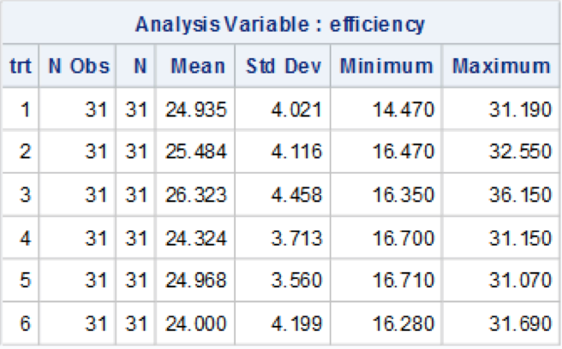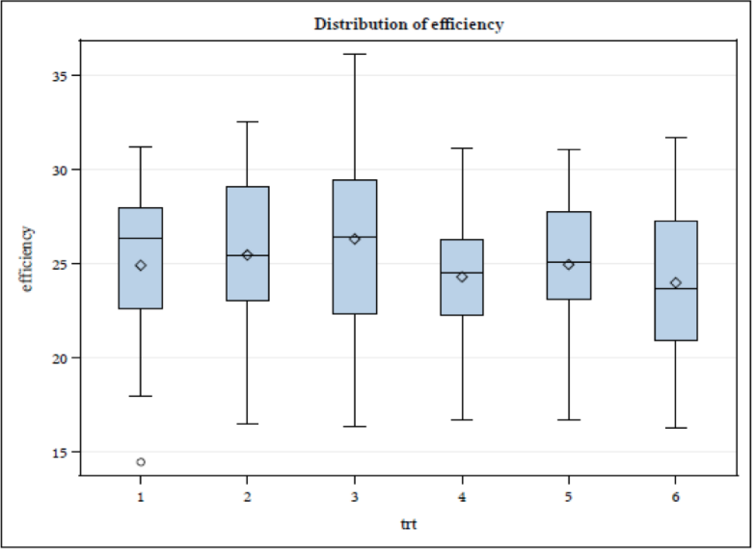

2. Parameter estimates and other hypothesis tests

2-1. Test for overall treatment effects:

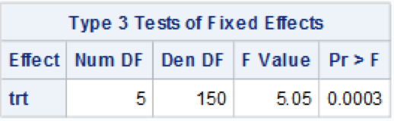

2.2 Test for random effects:

|  |  |
| --- | --- |
| Model with random effects | Model without random effects |
|  |  |

2.3 Estimates of Treatment effects:

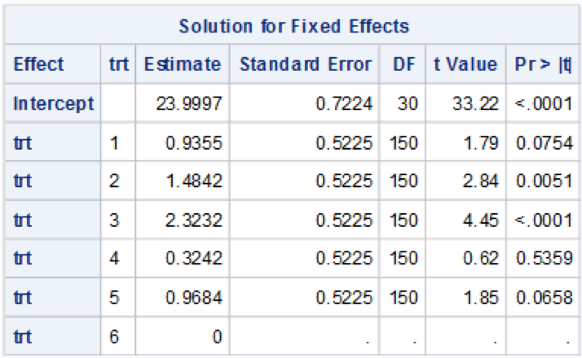

2-4 Estimates of Variances for random effects and experimental errors

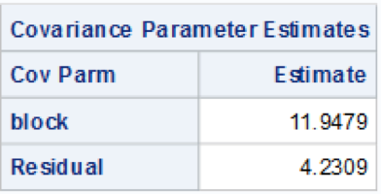

2-5 Contrasts

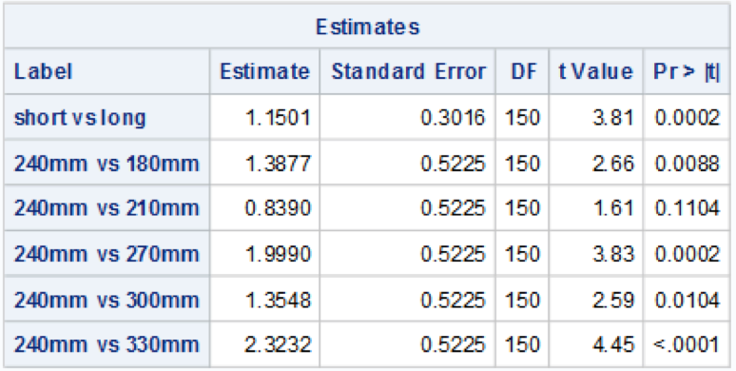

3. Model diagnostics

3-1. Normality

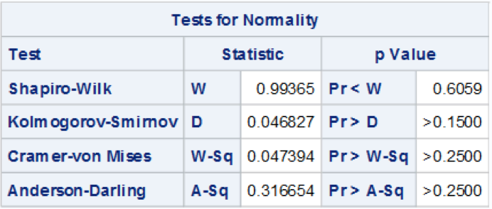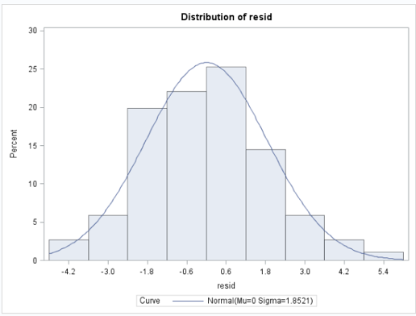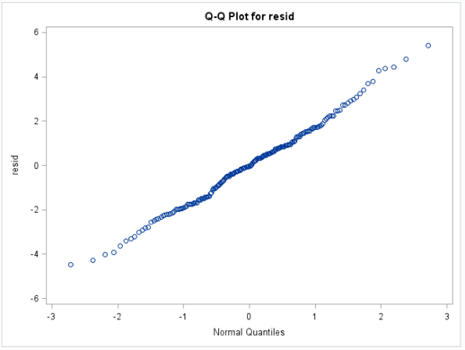

3-2. Homogeneity of Variances

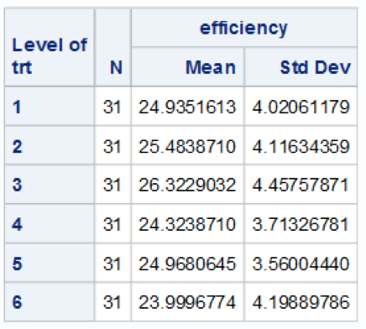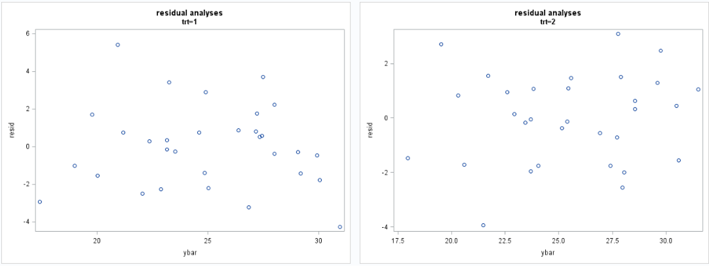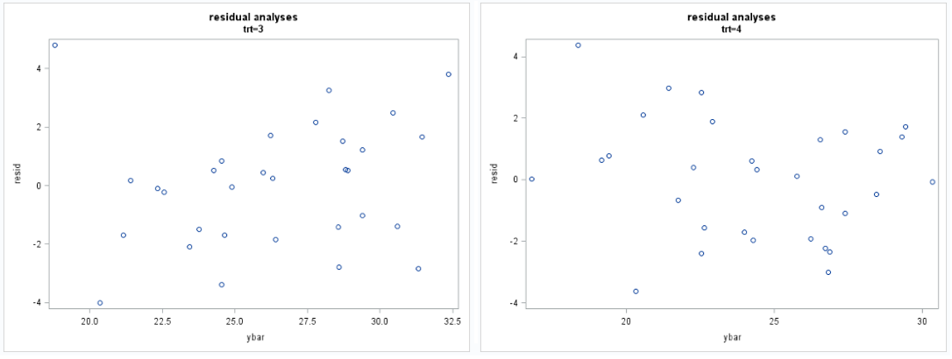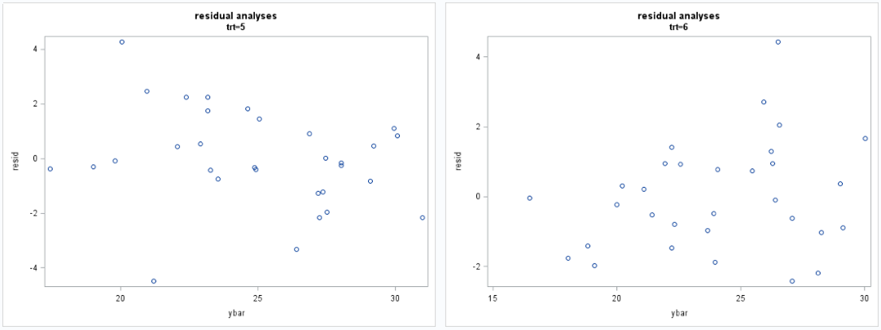

4. Sample size to ensure power greater than 0.8

